# **Name: Abdurrahman Qureshi**

# **Roll No: 210451**

Practical No: 9

**1) WAP in java to find the character represented by the ASCII value entered by the user.**

**CODE:**

import java.util.*;

class EXP8ASCII{

public static void main(String args[]){

Scanner sc = new Scanner(System.in);

System.out.print("Enter a number to see their ASCII Value:");

char n = sc.next().charAt(0);

int c = n;

System.out.println("ASCII value of " + n + " is ---> " + c); }}

**OUTPUT:**

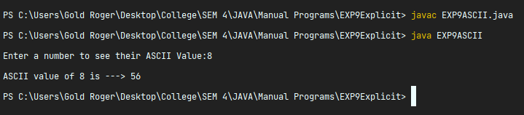

**2) WAP in java to convert double and float to integer**

**CODE:**

import java.util.*;

public class EXP9DFToInt{

static void DoubleAndFloatToInt(){

double dVal;

float fVal;

int iVal;

Scanner userEnteredValue = new Scanner(System.in);

System.out.println();

System.out.print("Enter an integer : ");

iVal = userEnteredValue.nextInt();

dVal = iVal;

fVal = iVal;

System.out.println();

System.out.println("Integer Value ---> " + iVal);

System.out.println("Float Value ---> " + fVal);

System.out.println("Double Value ---> " + dVal); }

public static void main(String args[]){

DoubleAndFloatToInt();}}

**OUTPUT:**

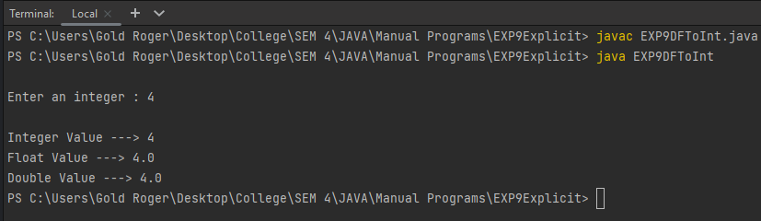

**3) WAP in java to convert centigrade to Fahrenheit**

**CODE:**

import java.util.*;

public class EXP9CelToFah{

static void CelsiusToFahrenheit(){

double celVal;

double fahVal;

System.out.println("Enter celsius temperature to convert to american : ");

Scanner userEnteredValue = new Scanner(System.in);

celVal = userEnteredValue.nextDouble();

fahVal = celVal + 33.8;

System.out.println();

System.out.println("Celsius Value ---> " + celVal);

System.out.println("Fahrenheit Value ---> " + fahVal); }

public static void main(String args[]){

CelsiusToFahrenheit();}}

**OUTPUT:**

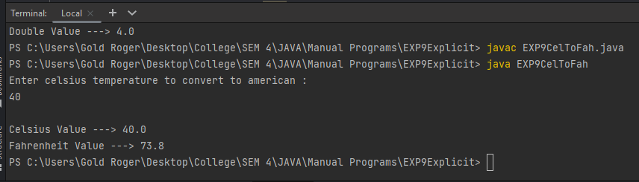

**4) WAP in java to print alphabetical pyramid**

**CODE:**

import java.util.*;

public class EXP9AlphaPyramid{

static void AlphaPyra(){

char ch = 'A';

Scanner sc = new Scanner(System.in);

int noOfCol = sc.nextInt();

for (int i = 1 ; i<=noOfCol ; i++){

for (int j = noOfCol-i ; j>=0 ; j--){

System.out.print(" ");}

for (int k = 1 ; k<=i ; k++){

System.out.print(ch + " ");

ch++;}

System.out.println();}}

public static void main(String[] args){

AlphaPyra();}}

**OUTPUT:**

